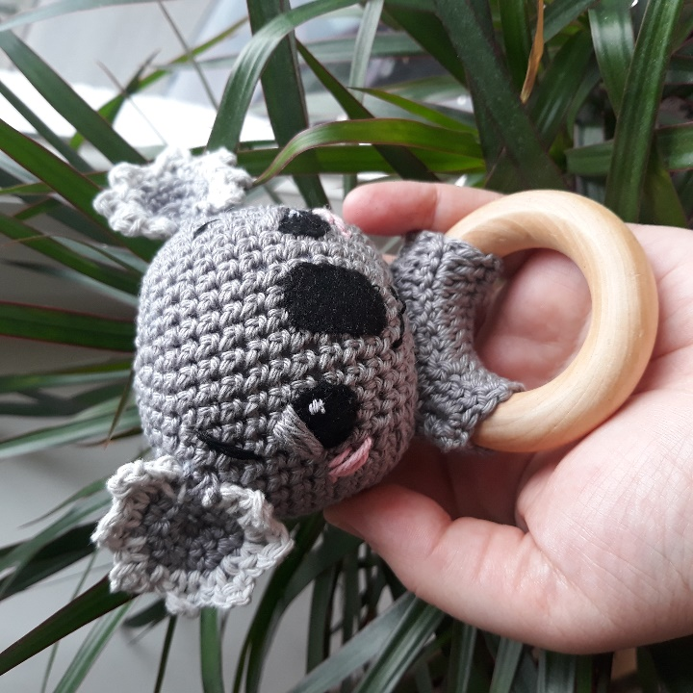
Koala
Teething
Ring

Head [from Red Heart Cutie Elephant Blankie, pattern here https://www.yarnspirations.com/row-en/red-heart-cutie-elephant-blankie/RHC0202-018800M.html#q=elephant&sz=12&start=14 ]:
Head Beginning at top of head, with B, ch 2.
Round 1: Work 6 sc in 2nd ch from hook; do not join—6 sc.
Round 2: Work 2 sc in each sc around—12 sc.
Round 3: Sc in next sc, 2 sc in next sc] 6 times—18 sc.
Round 4: [Sc in next 2 sc, 2 sc in next sc] 6 times—24 sc.
Round 5: [Sc in next 3 sc, 2 sc in next sc] 6 times—30 sc.
Round 6: Sc in each sc around.
Round 7: [Sc in next 4 sc, 2 sc in next sc] 6 times —36 sc.
Rounds 8–14: Sc in each sc around.
Round 15: [Sc in next 4 sc, sc2tog] 6 times —30 sc.
Round 16: [Sc in next 3 sc, sc2tog] 6 times —24 sc.
Round 17: Working in back loops only, *sc in next 2 sc, sc2tog; repeat from * around—18 sc.
Round 18: [Sc in next sc, sc2tog] 6 times—12 sc. Stuff head lightly.
Round 19: [Sc2tog] 6 times; join with slip st in first sc—6 sc. Fasten off, leaving a long tail for sewing. Weave tail through last round and pull stitches closed. Do not cut tail.

Ears [inspired by Red Heart Love Monkey pattern here https://www.yarnspirations.com/row-en/red-heart-love-monkey/RHC0334-020500M.html#q=monkey+&includeContent=true&start=1 ]:
Row 1: Work 5 sc in 2nd ch from hook; do not join, work back and forth in rows, turn—5 sc. Row 2: Ch 1, 2 sc in each sc across, turn— 10 sc.
Row 3: Ch 1, [sc in next sc, 2 sc in next sc] 5 times, turn—15 sc. Join colour.
Edging: *( sc1, [sc1, ch2, sc1 into first chain], sc1 in next stitch to join)* repeat

Piece for teething ring [from Bunny Teeth Rattle pattern by Kirsti M Testroote, here https://www.ravelry.com/patterns/library/bunny-teether-rattle ]
Ch 14.
Row 1: 1sc in the 2. ch from the hook, 12sc (13sts)
Row 2: turn with 1ch, 1sc in each sts from the previous row (13sts)
Repeat Row 2 until the piece is the length you want.

To Finish:
Stitch ears to each side of the head.
Use black felt to create eyes and nose, stitched on with coordinating cotton.
Use yarn or cottons to add eyelids, rosy cheeks, eye highlights, mouth and eyebrows.
Stitch wooden ring piece together around the teething ring then stitch the head securely onto this piece.
And you’re done!
If you make and share this please try to reference all three makers Michele Wilcox, Kj Hay, and Kirsti M. Testroote (and myself if you like) as each deserves credit for their great work.
If you have used this tutorial for yourself or your class, please tag me on Instagram!
@kats_crafternoon_delight_
Or feel free to email me at:
kats.crafternoon.delight@gmail.com

©Katrina Marshall 2020
Not for commercial use.

©Katrina Marshall 2020
Not for commercial use.

